Abbey HardSpeller Gets Runner-Up Spot

On Saturday, 15th October the BBC arrived in Stranmillis College, Belfast to hold the Northern Ireland heat of this year’s Hardspell competition for Key Stage Three pupils. Over eighty pupils from across Northern Ireland, along with their families and friends, made the journey to cheer on potential candidates for this year’s grand final in England.
After the first round only twenty two pupils remained. This number only slowly began to dwindle as the spellings got more difficult. Eventually, though, after hundreds of spellings being asked, the competition went down to its last four competitors with the Abbey’s Garbhan McKevitt going head-to-head with a female opponent who proved herself to be a worthy competitor. Garbhan, unfortunately, lost out when he had to spell the French word sang-froid, one of the words taken from a bank of two thousand words each competitor had to learn. As first runner-up in the competition Garbhan will be invited to London on an all-expenses-paid trip as first reserve for the final.

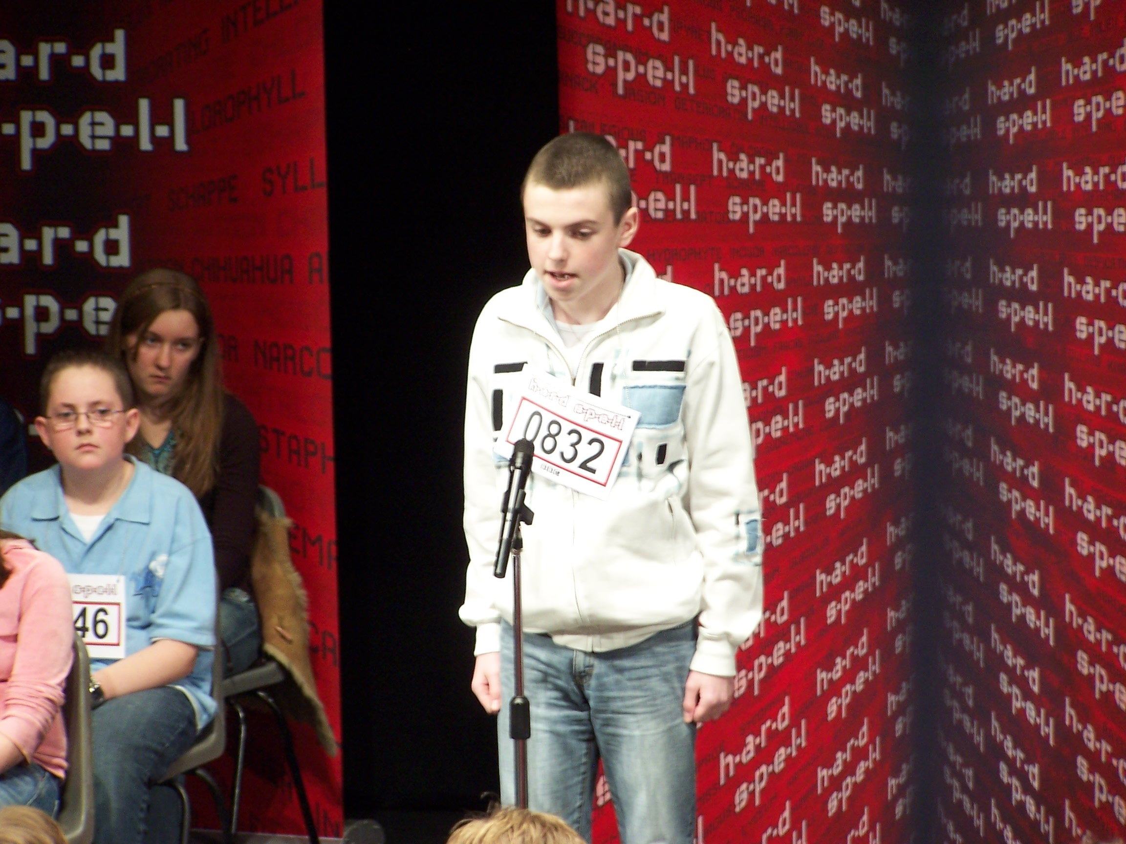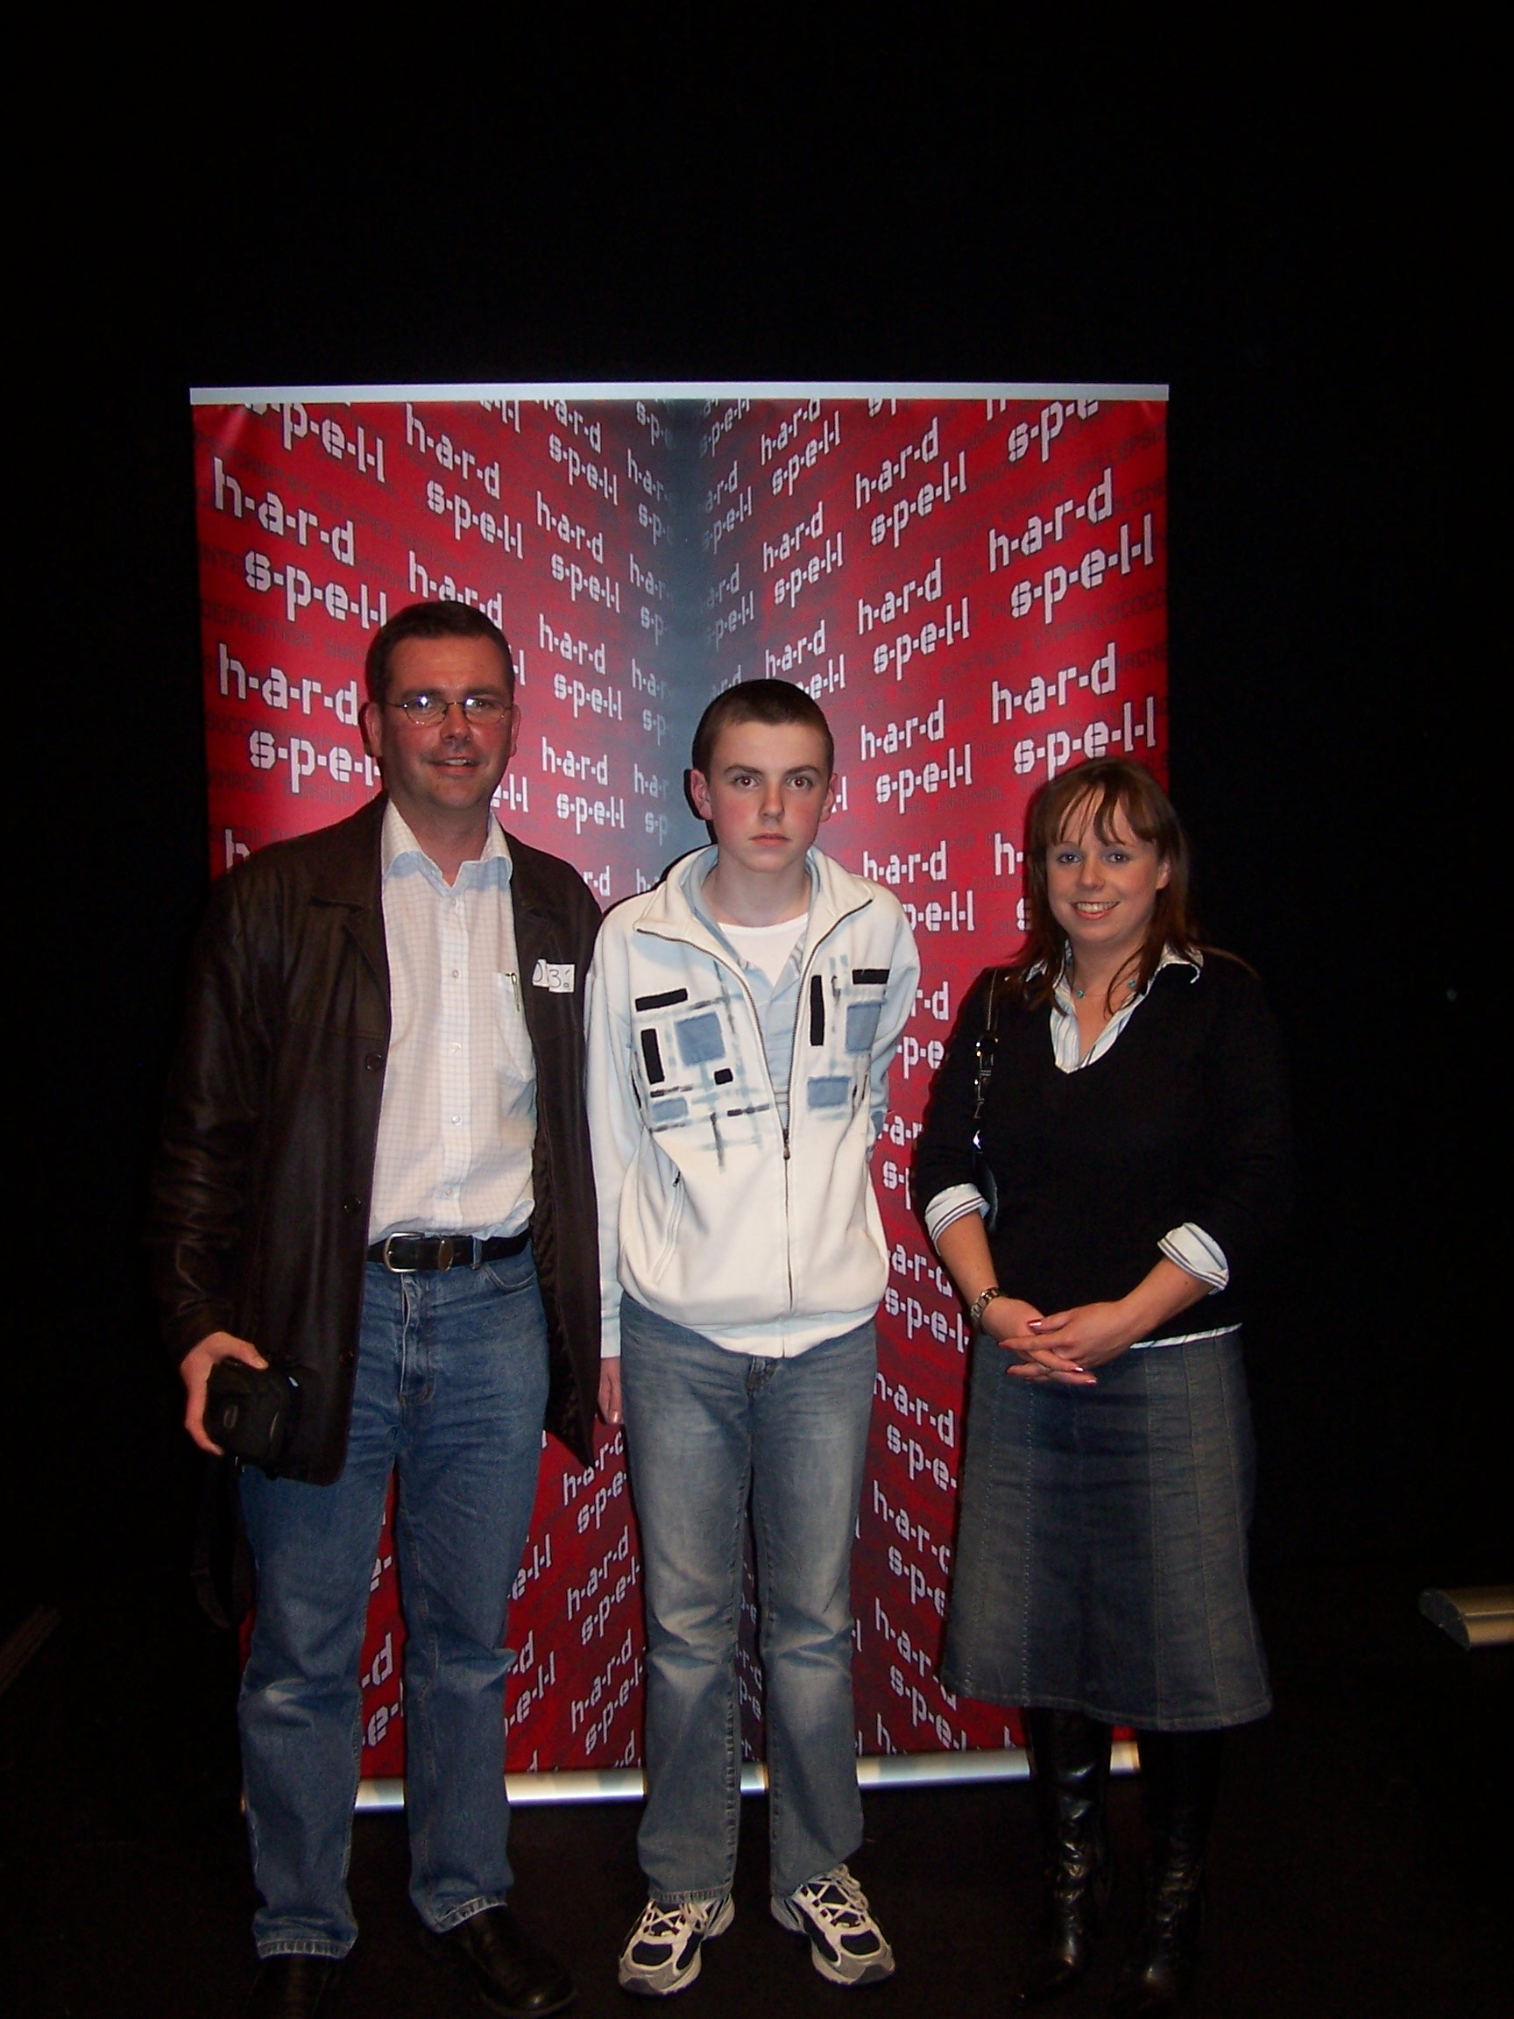
Testing time for Garbhan Garbhan with Abbey English teachers,
Mr. Mel McMahon and Ms. Patricia Mc
Aleese

