Local Student Hits Write Note

This academic year has proved to be a significant milestone in the life of 17 year old Abbey student, Philip Knox. Philip, a member of local band, the Jazzberries, who will be supporting Van Morrison in Newry Town Hall at the end of October, has also been the proud winner of two major poetry competitions in recent months. In September Philip discovered that he had won the Charlie Donnelly Poetry Competition for his age group and this month found that this achievement had been trumped when he was selected as a winner in the Foyle Young Poets of the Year 2005 competition. This competition, sponsored by the Poetry Society, attracted over six thousand entrants and Philip was one of only several winners to come from Ireland and Great Britain. Other winners came from locations as far flung as Singapore, New Zealand and the USA. Having attended the Awards ceremony in London, Philip said, “ I was amazed when I entered the auditorium to see my poem printed on a large banner with my photograph and biographical details beside it. It seemed somehow, unreal.” Poet Laureate, Andrew Motion, commended the prize-winners for their remarkable achievement. As part of his prize Philip will attend an all-expenses-paid writing course at the Arvon Centre, Lumb Bank in February next year. Here he will receive tuition from some of today’s best known writers.
Philip is also a member of the Abbey’s Creative Writing Group. In the last academic year almost eighty pupils in the school had their work published and short-listed for a variety of competitions and anthologies. Below is Philip’s winning poem for the Foyle Young Poets Competition.
Untitled

a friend
just told
me
that
her
one-year-old
sister’sboyfriend’scousin

choked.
to.
death.

shortly before his mother
went into
labour
with
(what would have been)
his new baby brother.

before slipping blankly back
into the
dulling lukewarm
wash of the
everyday,
I thought it
only right
(but nothing more)
to write
some words
which will never
warm the heart

of the
impossibly
small
tangled
body
prone
in some
living-room.

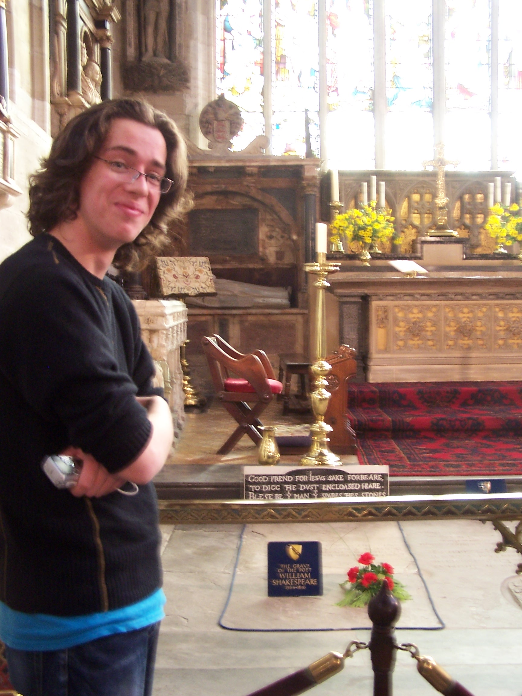

Philip Knox on a recent school
trip to Stratford

